Recursion:

- make input small

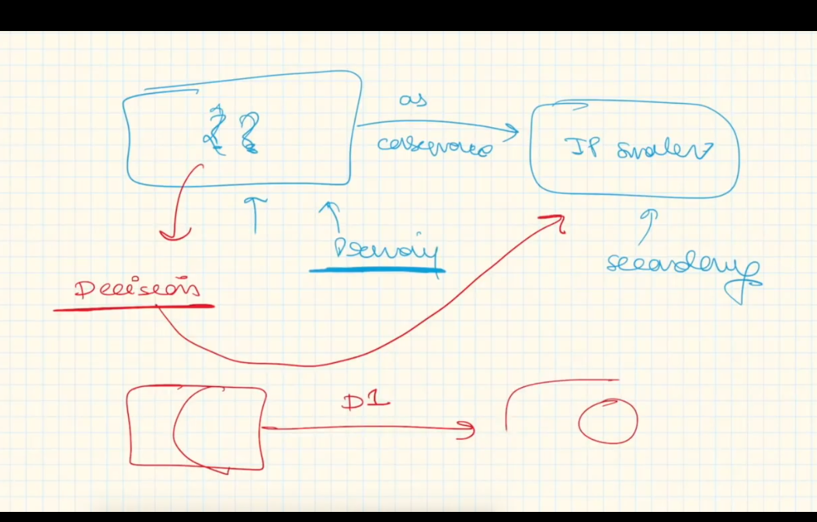

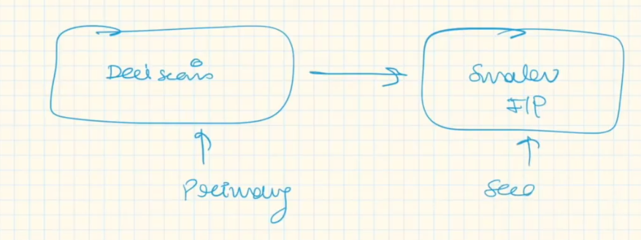

- decision is primary to solve or make the input smaller.

- decision making is primary goal.

2: when to use recursion:

- to find the decision space for the identification

- to identify whether the problem is recursive or not we have provided the choice and decision in the problem.

- based on the choice and decision we represent the problem in form of decision space and solve using the recursion.

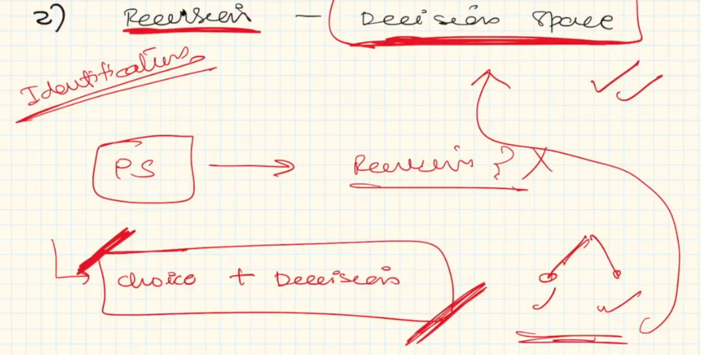

3: Recusive tree:

- for problem if we find the recursice tree then the writing the code is easy.

-  representation of decisions.

Input output method:

-

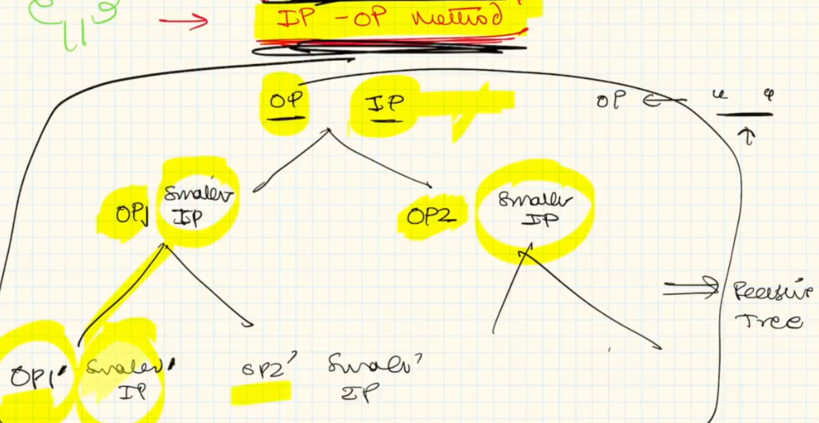

Suppose for substring problem to get the string `ab` :

- selecting the branch is the making decision, by taking decision we make the input small.

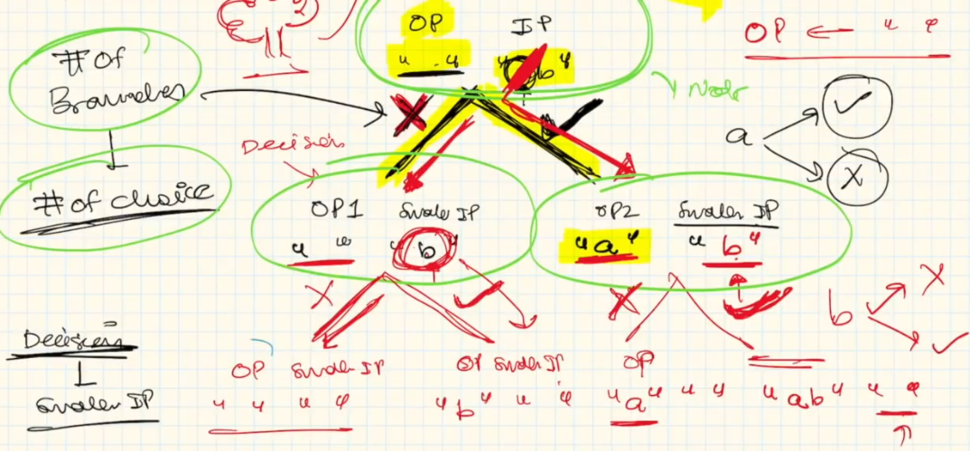

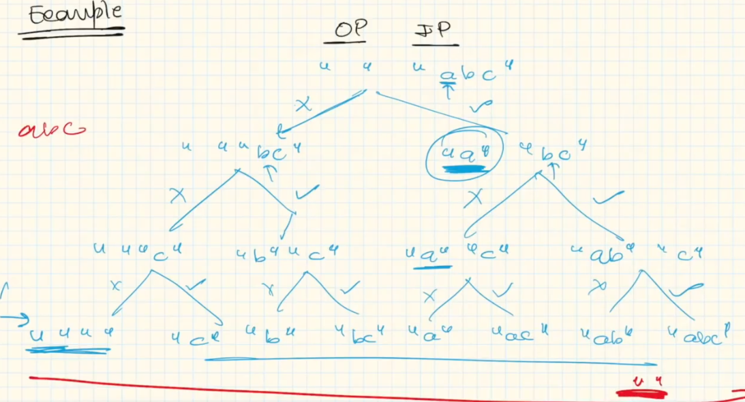

 * 2 Steps to solve the decision tree:

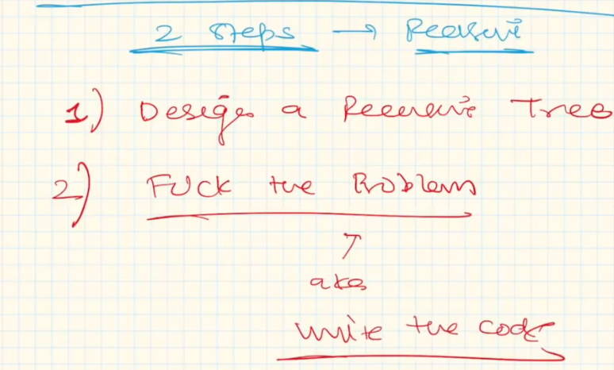

Recusion is everythere:

- in tree graph, string, array, heap, stack etc.

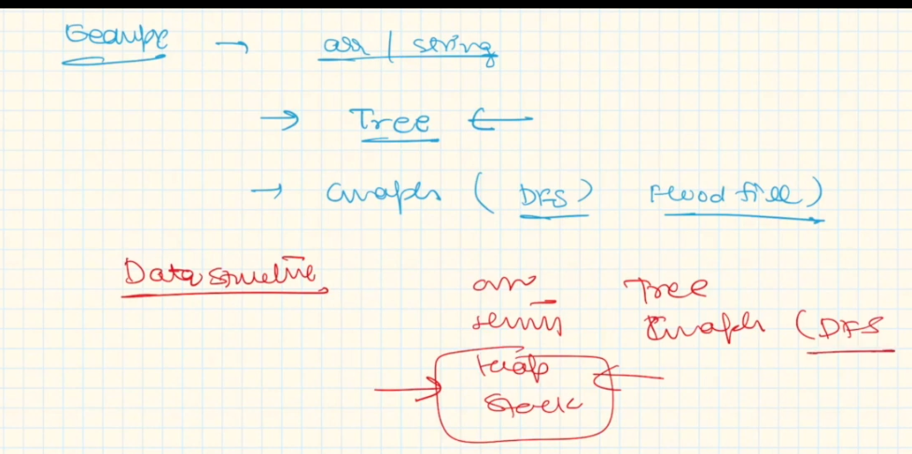

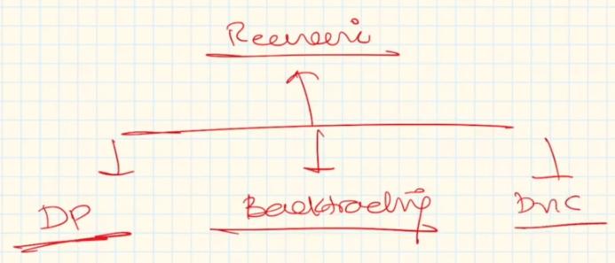

Recursion questions:

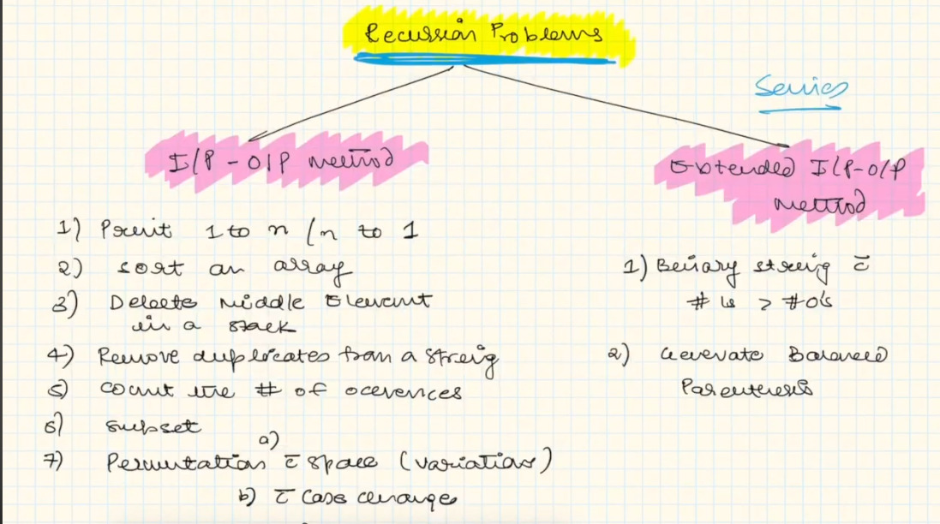

Base condition : Hypothesis : Induction

IBH

-useful in tree, linked list method.

For e.g. of print 1 to n;

Approaches to solve the recursion problem:

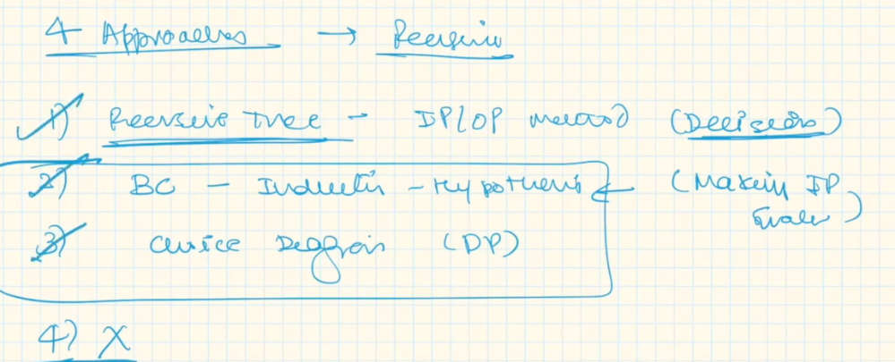

For base condition:

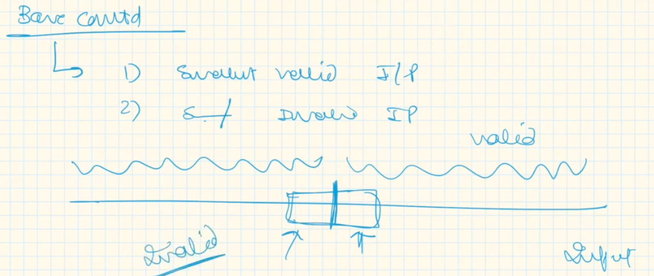

Problem: to print 1 to N:

1: Induction : what is going to pring.

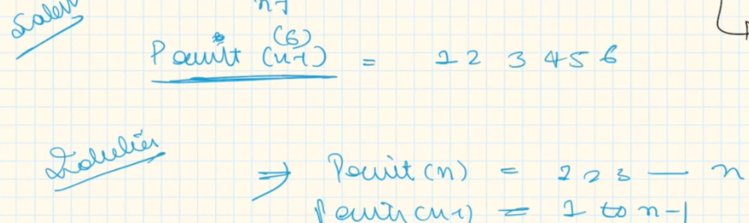

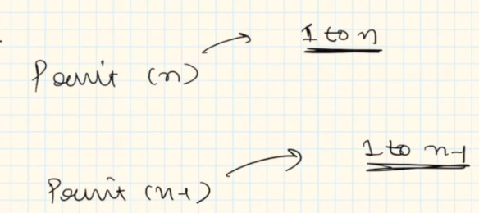

2: Base condtion:

- smallest valid input : 1

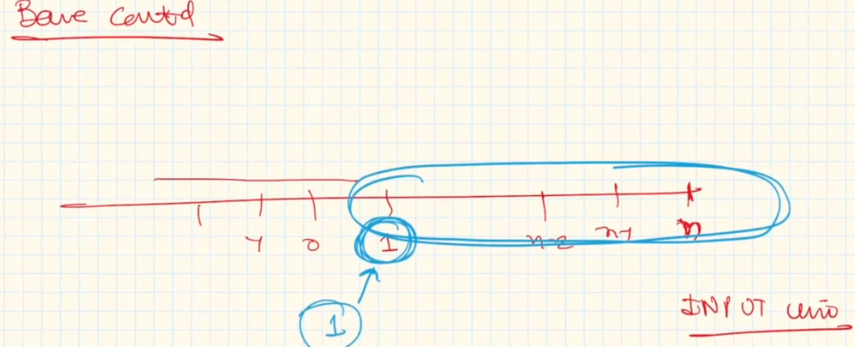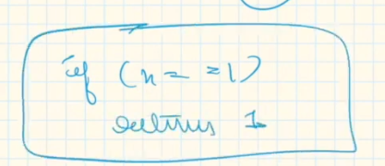

Hypothesis:

- what is going to design

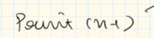is hypothesis for our print 1 to n problem.

Base condition

Hypothesis

Induction

Showed in following diagram:

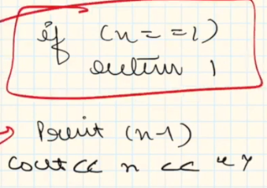

Why not used recursion tree?

- this is not kind of real recursion problem

- real recursion problems are solved using recursion tree only.

**So the flow to solve the recursion can be:**

**- if (can solve using IBH)**

**Then solve using IBH**

**Else if (can solve using recursion tree)**

**Then solve using recursion tree**

**Else if (can solve using choice diagram)**

**Then solve using choice diagram.**

Height of Binary Tree:

Problem statement:

- find the height of the binary tree

Input : function return the height of tree.

- has input of start node or root node.

Step 1: first find the hypothesis

1: find hypothesis on smaller input.

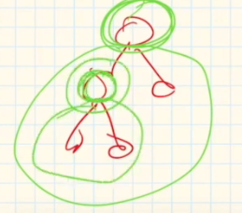

Height(root): return the height of tree

Height(root->left): return the height of left tree, and same for Height(root->right)

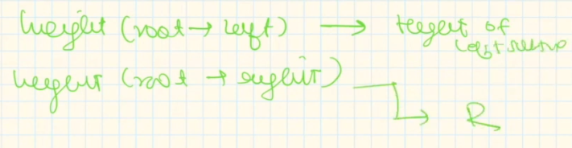

Step 2: Induction:

- return the 1 + max(height of left tree , height of right tree)

Step 3: Base condition:

- 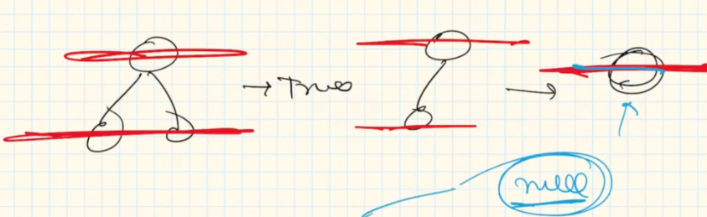

- smallest valid input is null.

- so height is 0.

Problem: Sort an array:

- TC will be more than nlogn.

- try to find the decision, if unable to find the decision, then use the smaller input to identify decision:

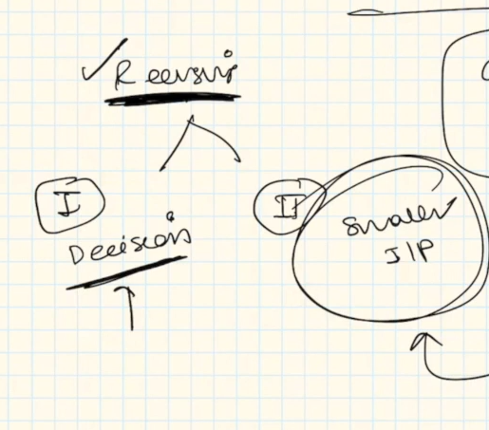

If decision problem then use decision tree, if smaller input problem then use Base, Hypothesis, Induction.

1: Hypothesis:

- how sorting will work?

- sort(arr)

- now make inout smaller.

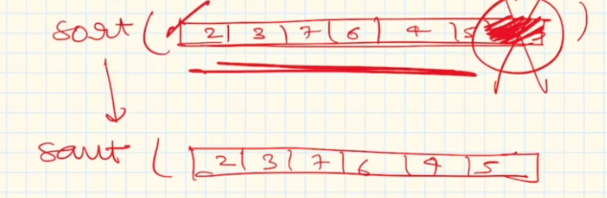

2: Base condition:

- min size can be : 0

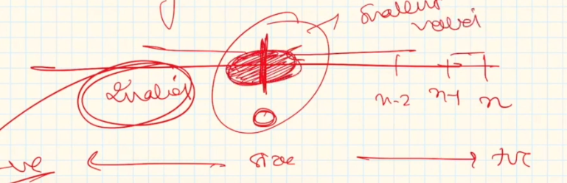

- base condition can be the array with single element.

If (v.size() == 1) : return;

3: Induction: how hypothesis step will work until the base condition?

- how the removed element at each hypothesis step will add into sorted array?

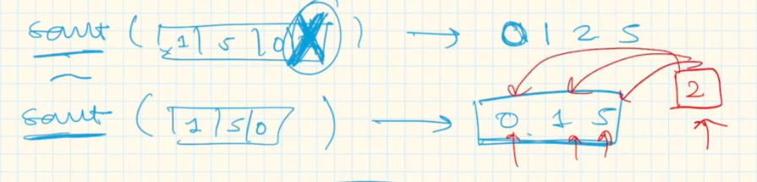

- we can apply the insertion sort technique to insert 2 into the sorted array at correct position.

- again we apply recursion to put the 2 into the correct location in the array.

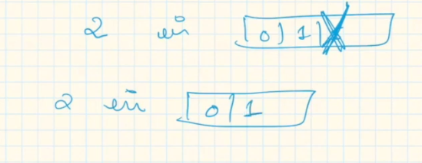

- to minimize the comparision:

We can check if vector is empty or last element in sorted vector is smaller than element to be added.

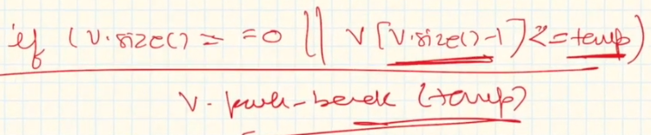

Hypothesis to add element into the sorted array :

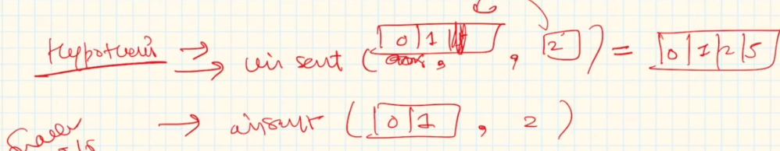

Array : 0, 1, 5, 2

Sumup :

Step 1: reduce the input each time, i.e. remove last element and add it to the sorted array.

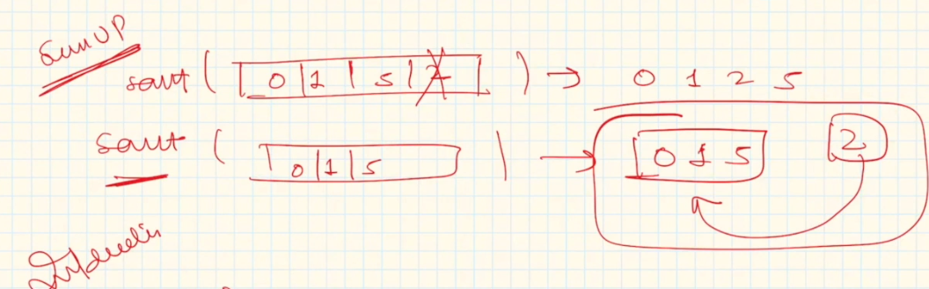

- to add the element back into the array, we uses insert function:

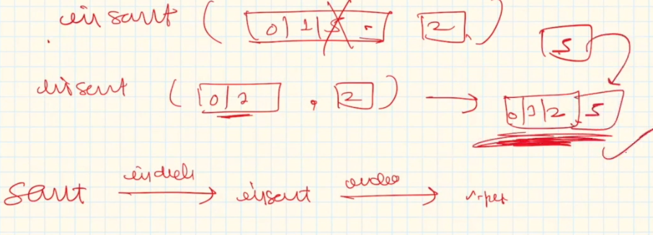

- induction step for sort function:

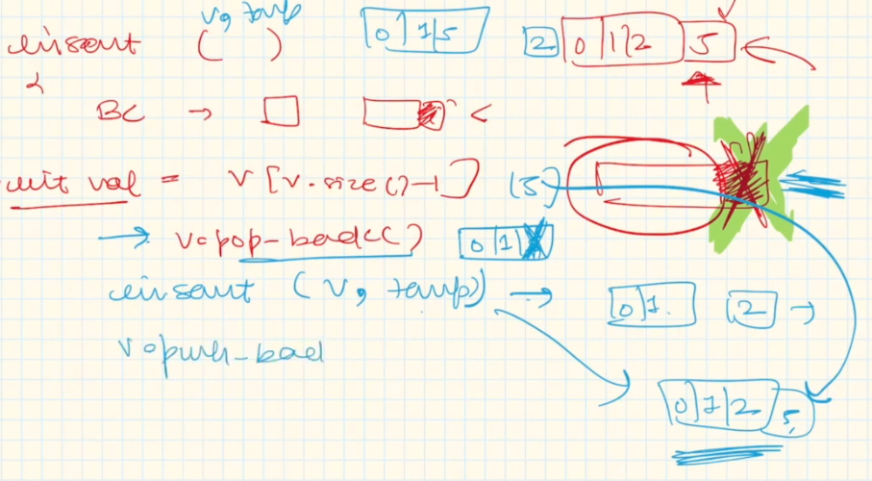

Code for sort function :

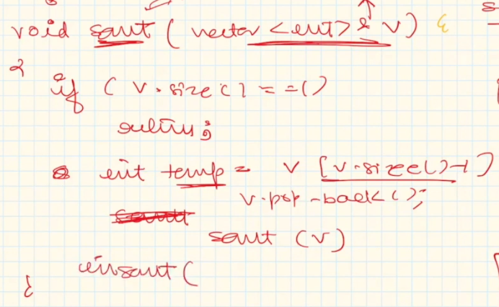

Insert function :

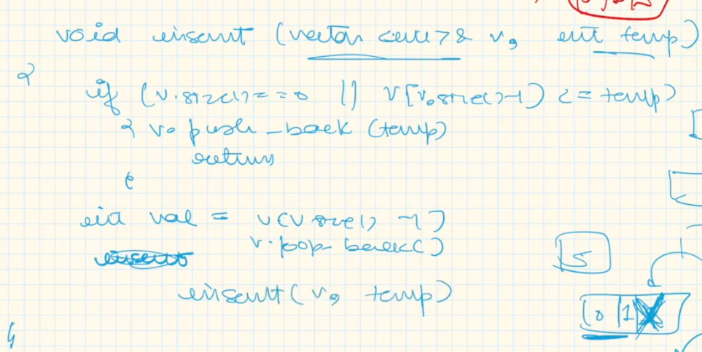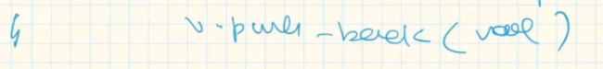

** Sort a stack :

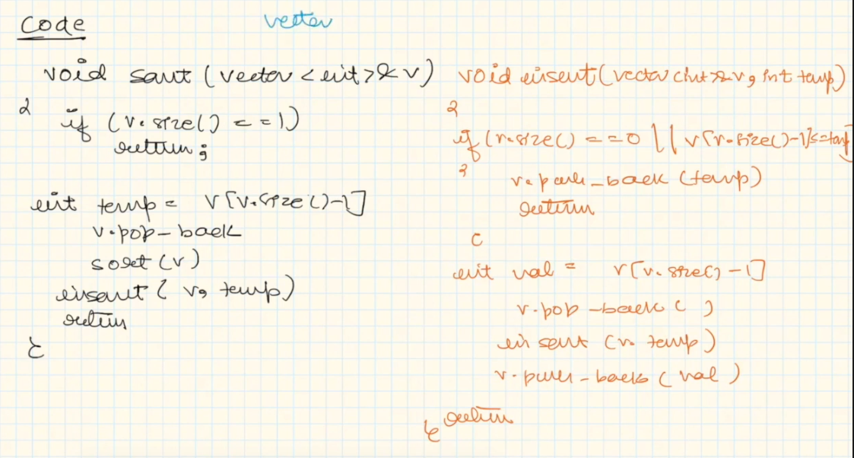

** Delete middle element of stack:

PS: iP: stack

OP: Print middle element. i.e. Size/2 + 1

- print middle element from the top.

- we have stack and k (location of middle element).

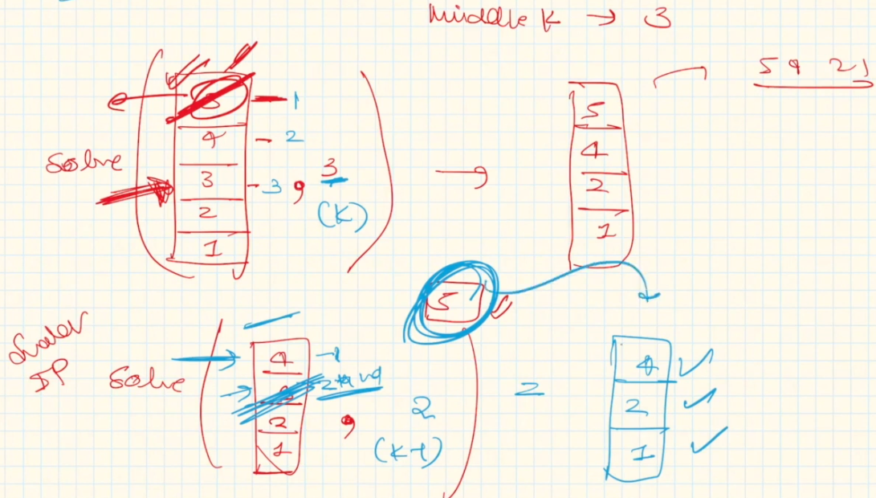

Hypothesis:

- reduce the input by deleting the top element every time.

- store top deleted element.

- then call the solve(stack, k-1) again

- then restore the top element to the stack.

\BC:

- smallest valid K can be 1 when it get reduced every time.

If (k == 1) : then pop the stack, and return.

Induction:

- Just push the stored top element during hypothesis time onto the stack.

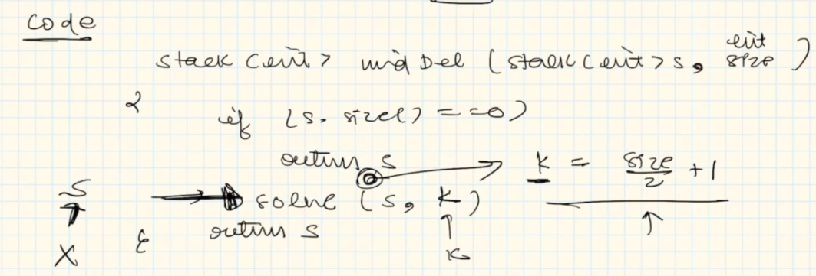

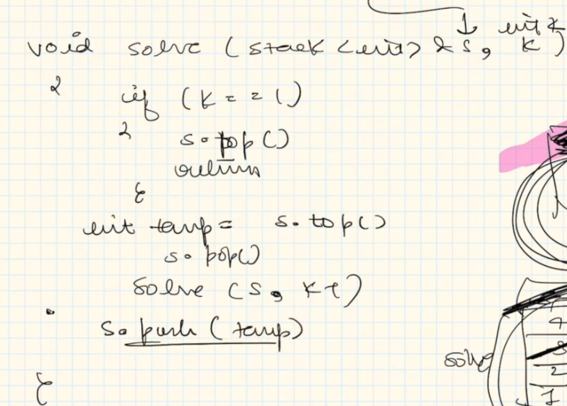

** Reverse a stack.

PS:

IO: stack

OP: reversed stack.

Hypothesis:

- reverse the array every time by making input smaller

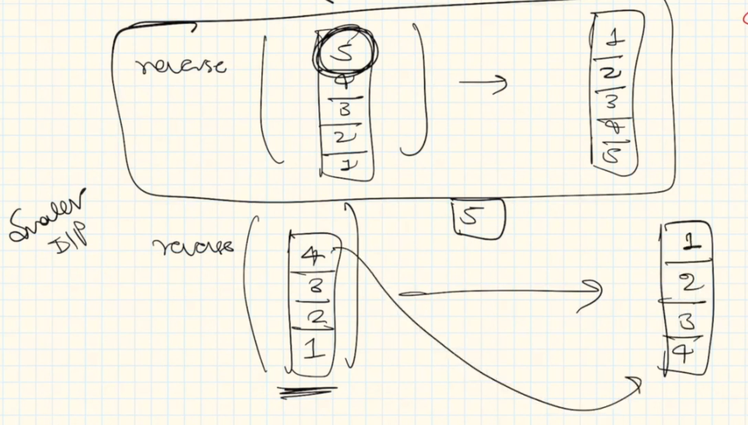

Base case:Empty stack.

Induction step: push back the element which we popped in hypothesis phase.

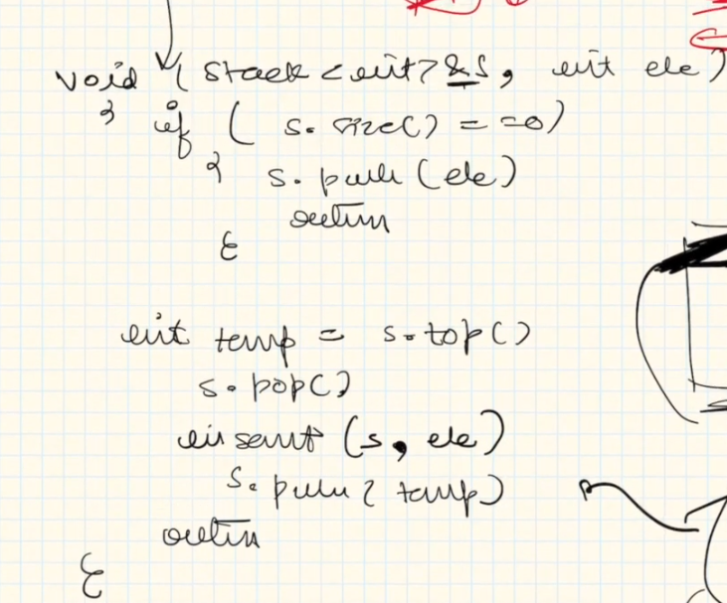

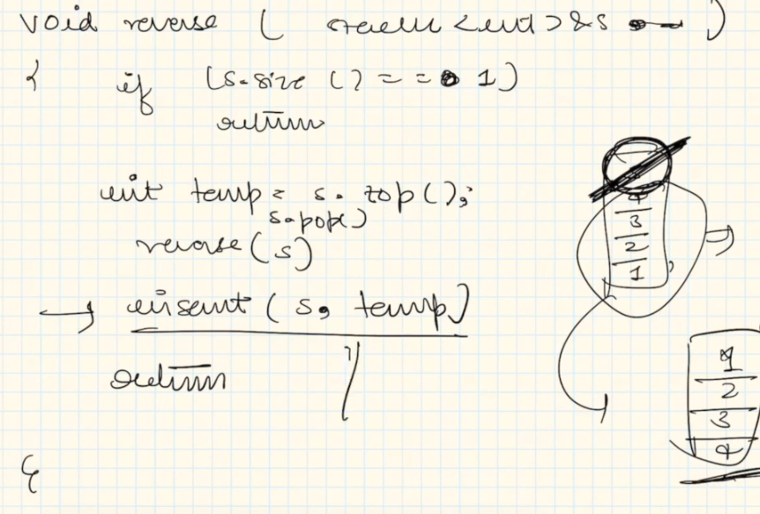

Kth symbol in grammar:

- input: n, k

- n defines row.

- k defines column.

Base condition:

- n = 1, k = 1 : gives 0l

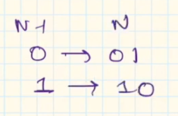

- if previous row has 0 then next row has 01

- if previous row has 1 then next row will be 10.

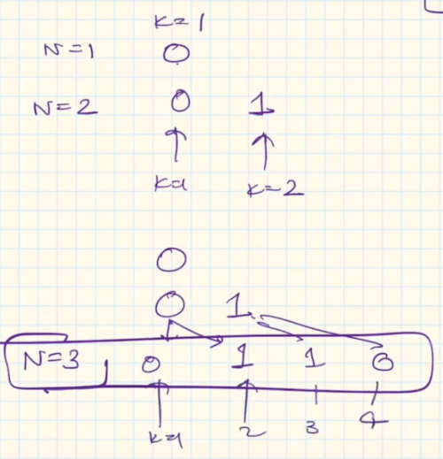

IBH method:

Hypothesis:

1. for solve(n, k) function , it should return the 0 or 1 based on the value at that location.

2. make smaller N and k.

- can reduce N by 1, but can’t do same thing with k, because every time row gets double.

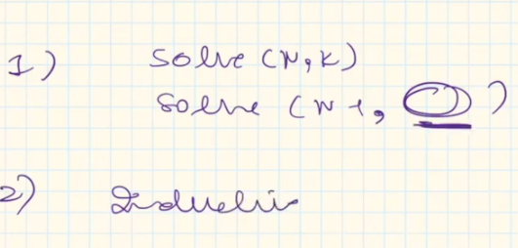

- 1: how to define the value of k, in hypothesis

- 2: what induction we required to transfer solve(n-1, ?) step to solve(n, k) step?

Pattern in the grammar:

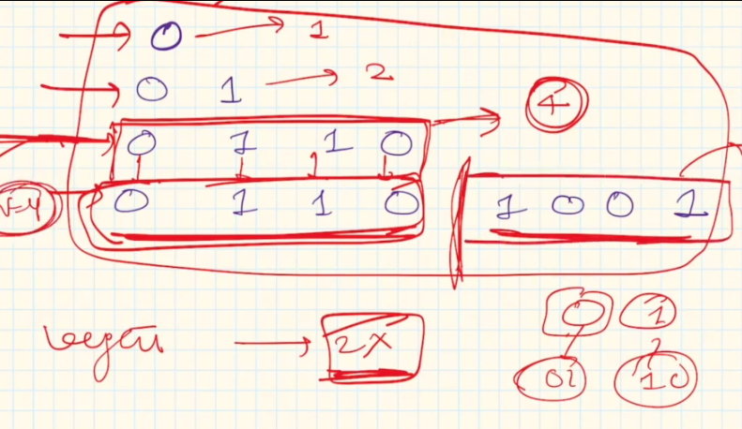

- first half of nth row is same as in previous row.

- second half is complement of elements from first half or previous row.

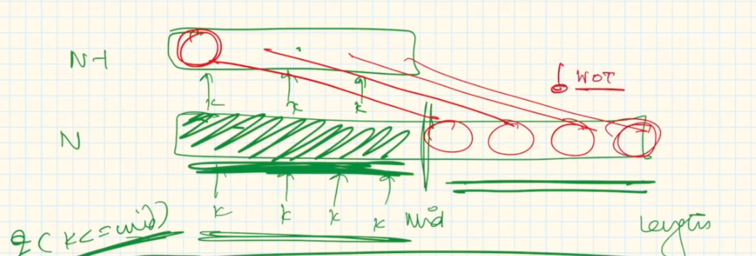

Logic :

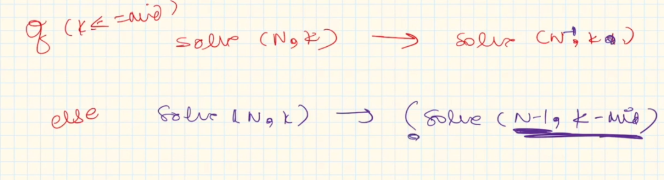

Hypothesis: same as the above

Base: return 0 when n==k==1.

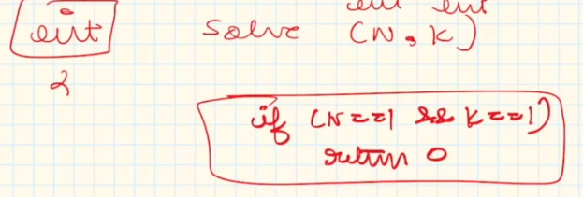

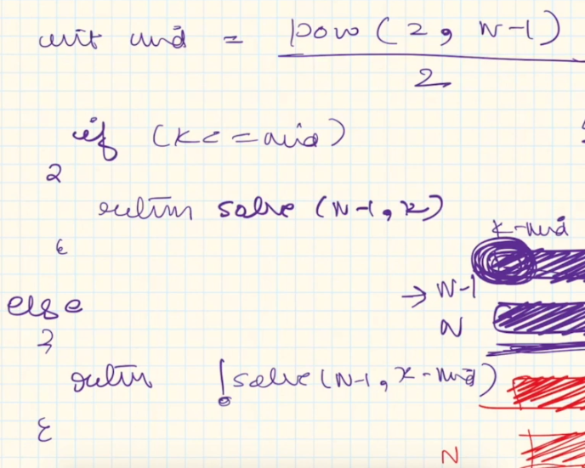

** Tower of Hanoi:

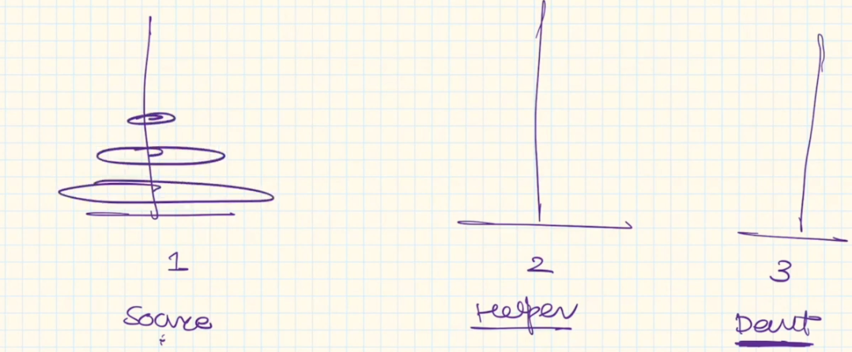

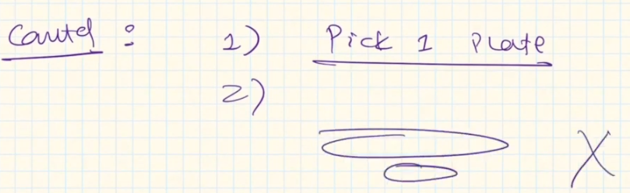

Hypothesis:

- The function solve(n, s -> d, h) performs the operation.

N: no of disk.

S: source tower.

D: destination tower.

H: helper tower.

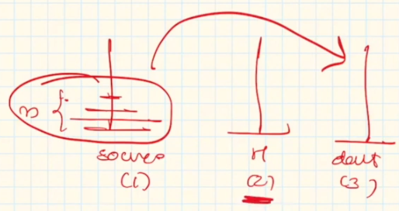

Think about the smaller input.

- talk about above 2 plates,

- put 2 plates from s to h.

Induction:

- then put remaining last plate from source to destination.

- all plates from helper to destination.

Base case:

- smallest valid input, single plate on source tower.

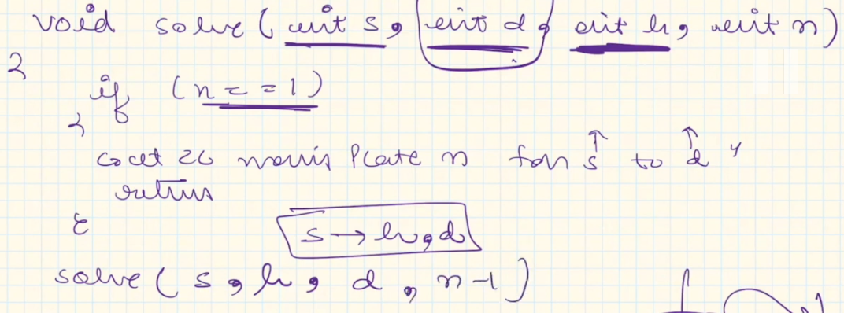

- last line : moving all n-1 dishes from source to helper so that we can move last plate from source to destination.

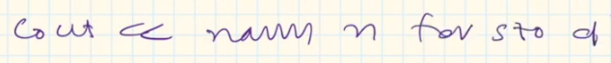

- now need to move n-1 plates from helper to destination.

- So we take help of source tower. So all n-2 plates from helper to source and remaining n-1 plate from helper to destination.

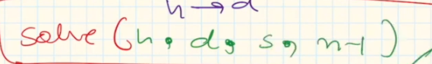

Return .

END…

- can use count variable to count the number of steps required to move all plates from source to destination.

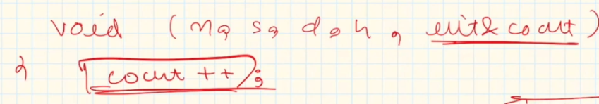

** Print Subset :

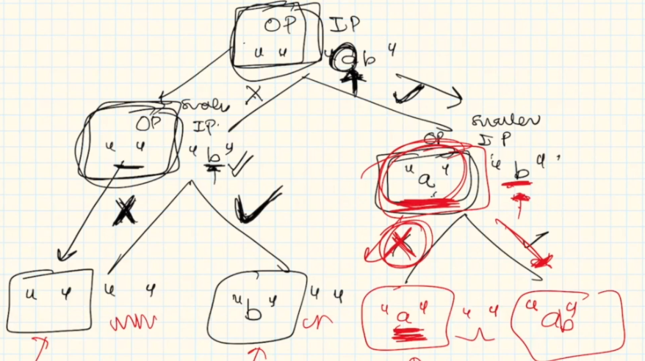

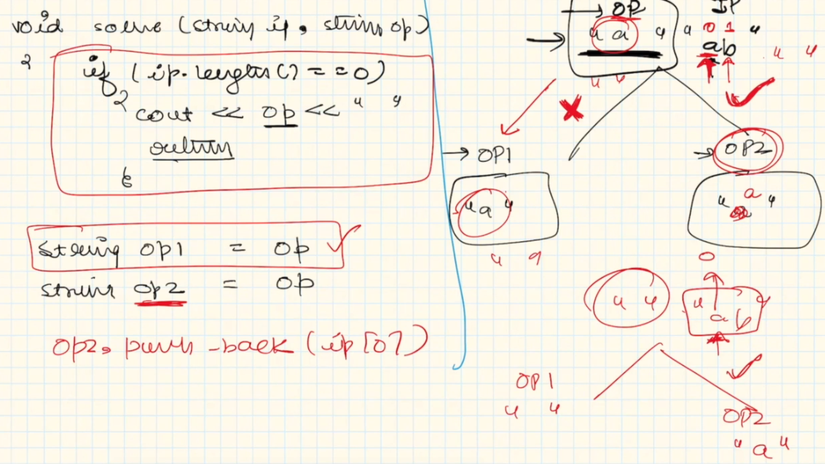

- reduce the input :

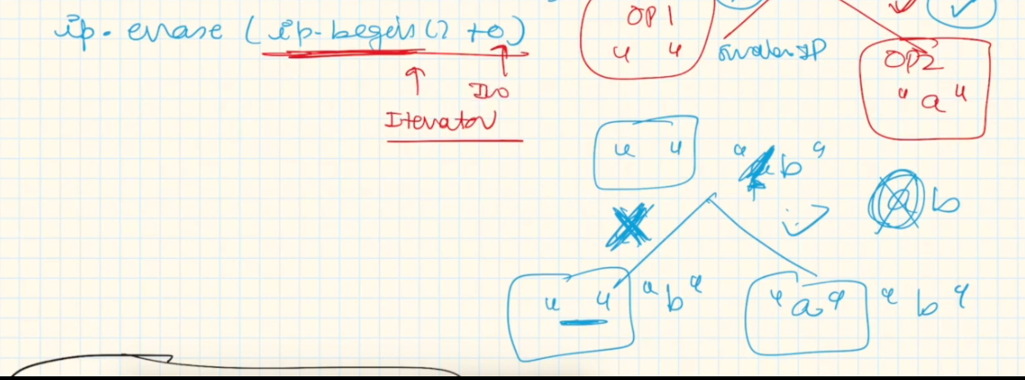

- recursively call the solve function for both op1 and op2.

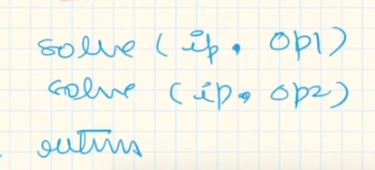

** Print unique subset:

- for string like aab, subset from above program will not be unique.

- synonyms :

- print all subset

- print power set.

- print all sub-sequences: sub-sequence is little bit different

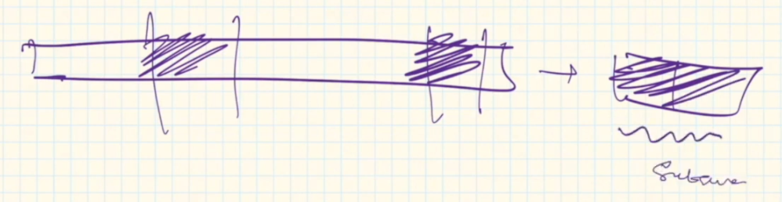

**Subsequence** may not be in continuous order, order is matter in subsequence

In **subset** the order is also not matter.

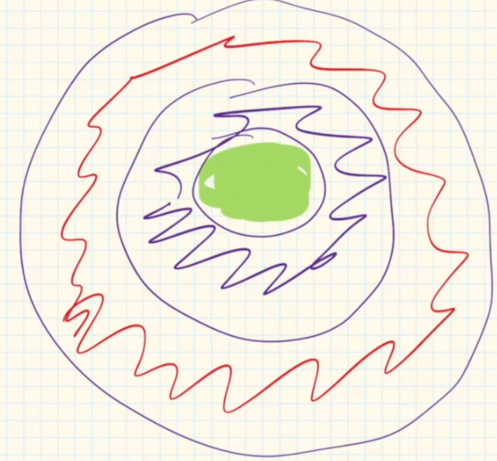

Green : substring

Blue: sub sequences

Red: subset

For string abc :

Subsequence : “”, a, b, c, ab, ac, bc, abc.

Subset : subsequence + ba, ca, cb, cba, cab, bca, bac, acb.

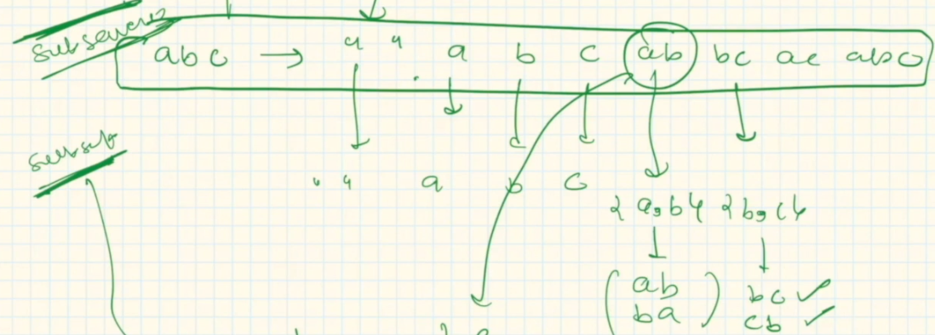

- so at end if power set, subsequence, all subsequence asked, you always use the subset question.

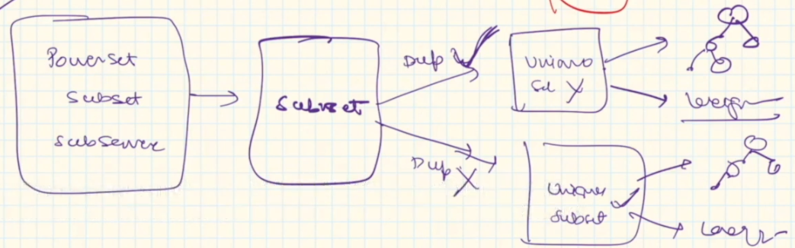

** Permutation with spaces:

- IP: string : eg: ABC

OP:

- A <space> B <space> C

- A <space> BC

- AB <space> C

- ABC

- means we need to insert the spaces between the alphabets.

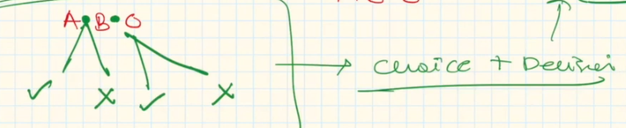

- choice: include letter with space or include letter without space.

- first letter to be include without space.

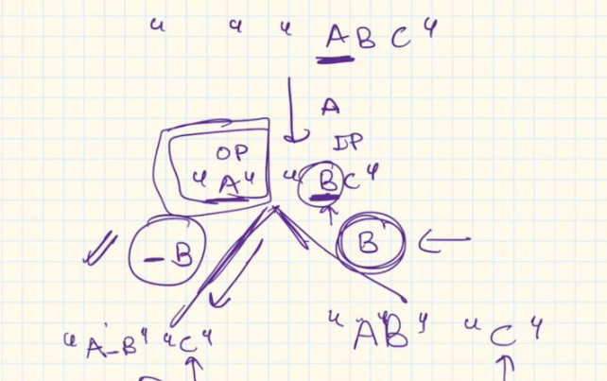

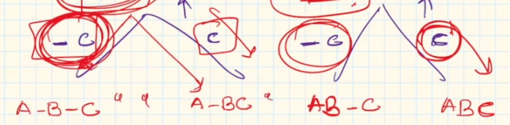

- at starting we need to include the start symbol from string into the output string.

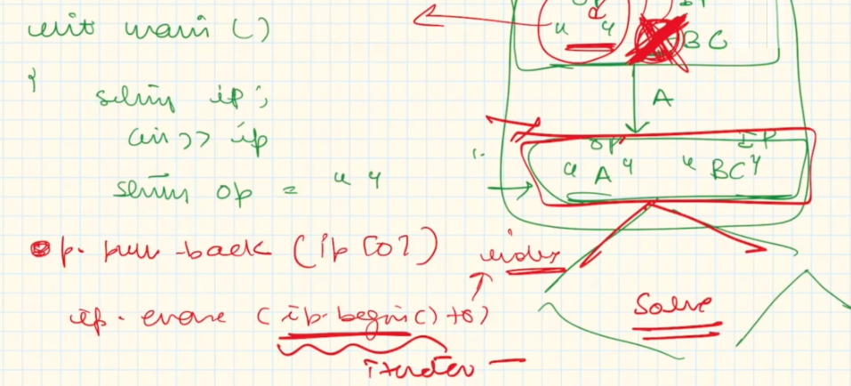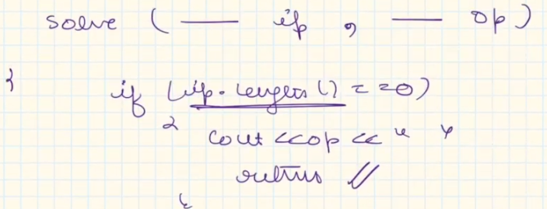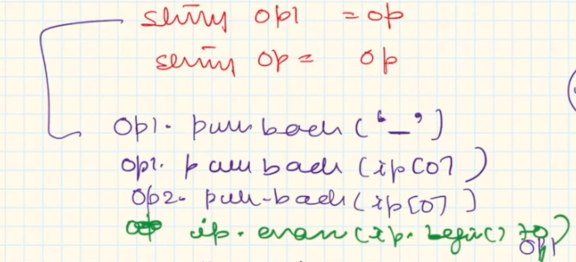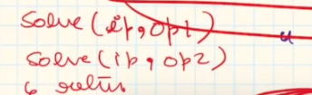

** Permutation with case change:

- Ip : string AB

- OP: ab, aB, Ab, AB.

**EASY LIKE ABOVE**

**\*\* Letter case permutation:**

- input: letter can be in any case, digits are included.

- e.g.: a1B2

- output:

- a1b2

- a1B2

- A1b2

- A1B2

- letter is same as it is.

- tree will be like following:

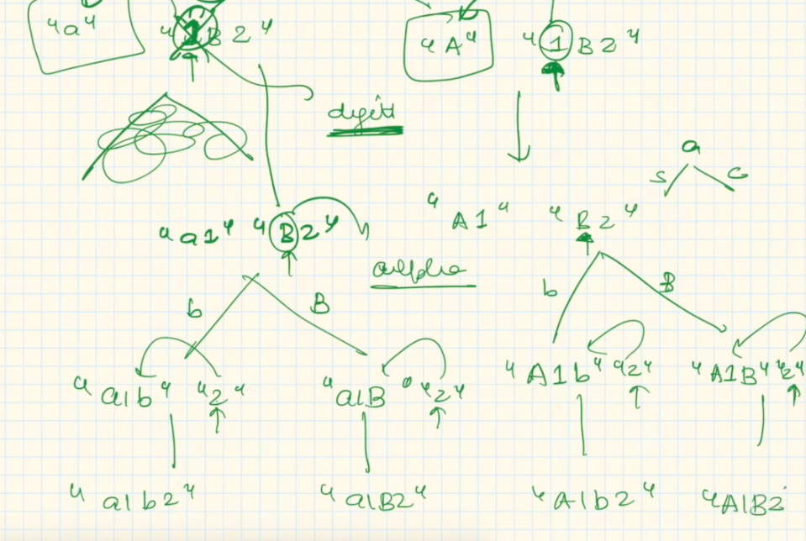

Code:

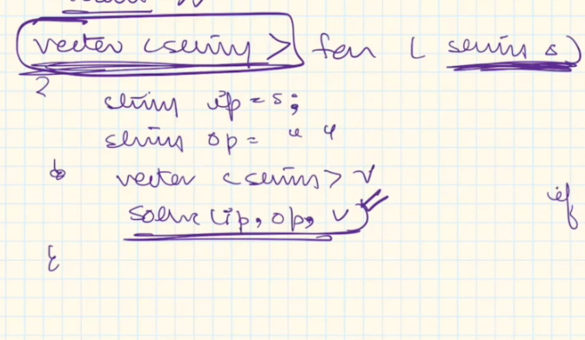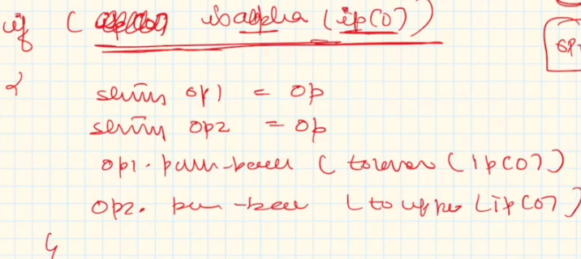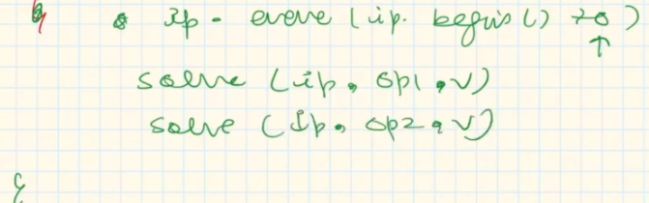

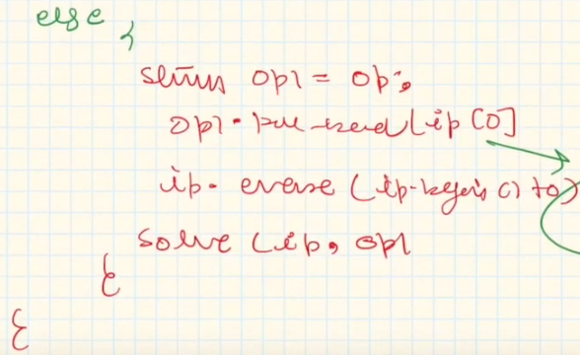

**\*\* Generate all balanced parenthesis.**

Input: n = 2

Output: generate all balanced parenthesis.

- n=2: ()(), (()).

- n=3: ((())), ()()(), ()(()), (())(), (()()).

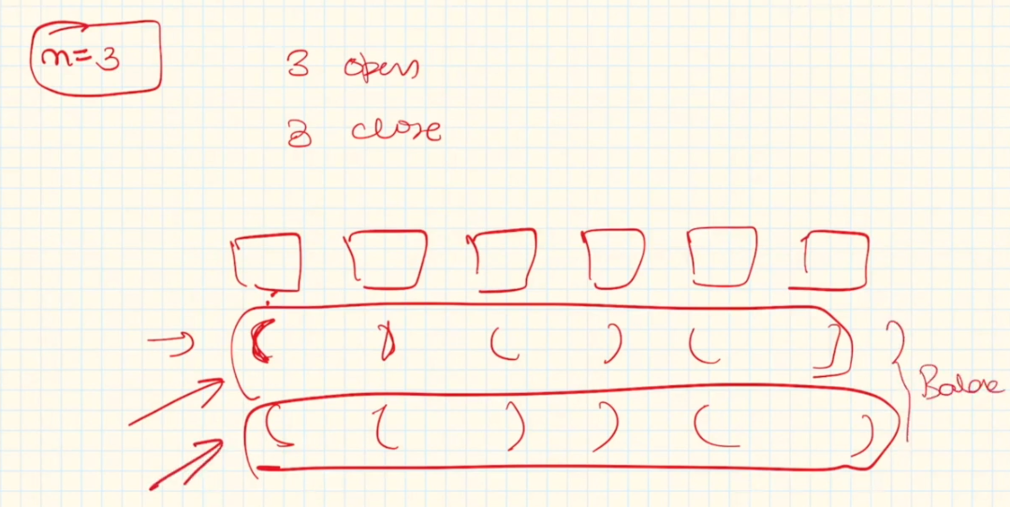

- define open: 3, close: 3, to track the number of parentheses.

- start bracket should be open (, and end bracket should be closed bracket.

Next:

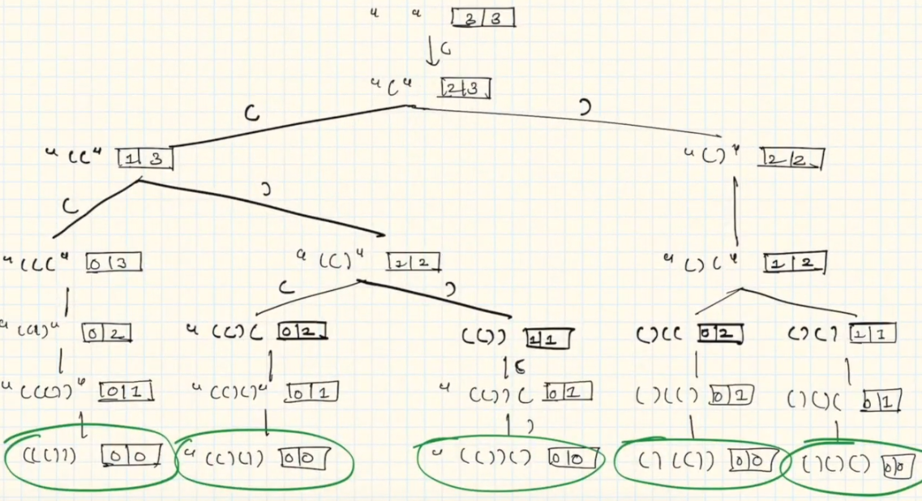

Sometime 2 branches used or sometimes single branch is used.

What should be the solid condition?

- at every branch we can use opening bracket, but we use closing bracket sometimes or sometimes not.

- we get the closing bracket only when **(close > open)**

Code: main function

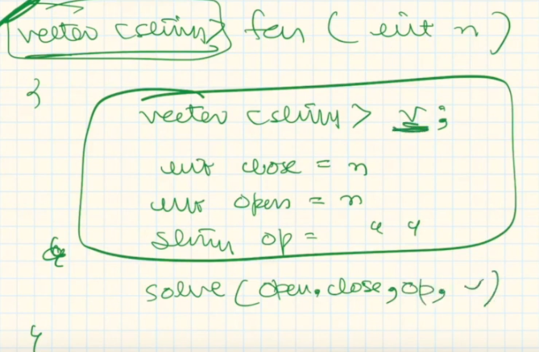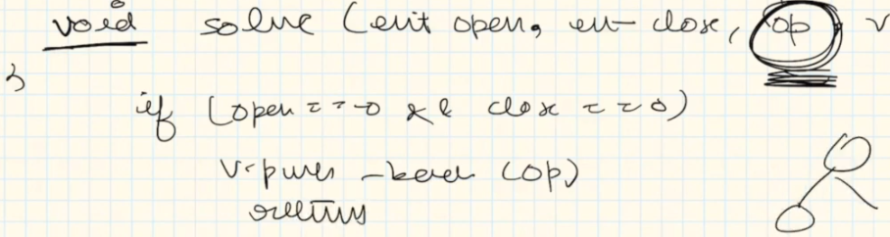

- we always have option for open bracket, so use them.

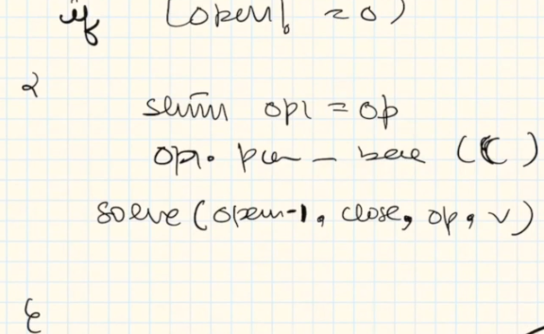

- check for close bracket condition.

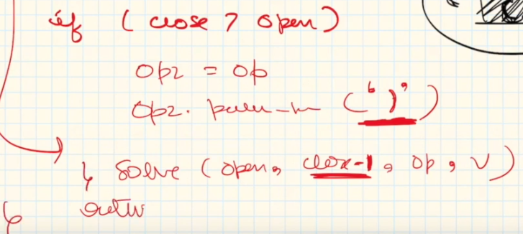

** Print N digit binary numbers having more or equal 1 than 0 for any prefix.

Breakdown: e.g. for number 11010

Prefix are: 11010, 1101, 110, 11, 1.

- last 4 called as proper prefix.

- Input: N: number of digits in binary number.

- output: N digit binary number, having more or equal 1 than 0.

- **Prefix tree:** at start we cannot use 0, for e.g. 011 : if 0 is prefix then our case becomes false.

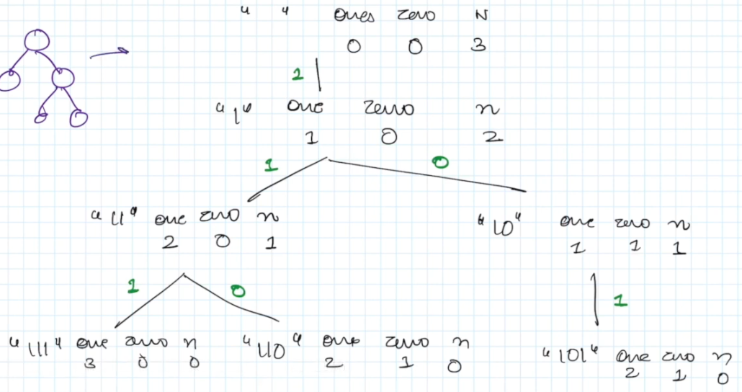

We get knowledge from above recursive tree:

- choice for 1 is always available.

- for 0: the 0 choice is available when number of 1 >= number of 0.

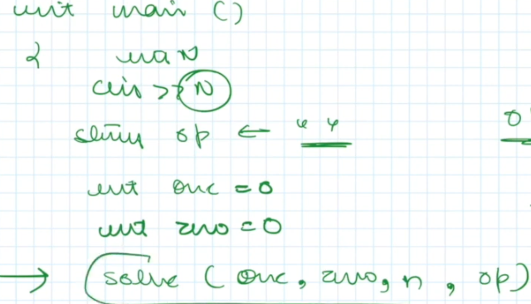

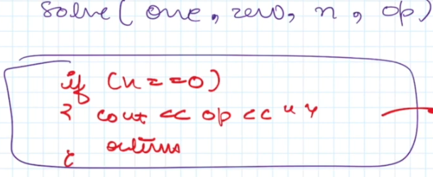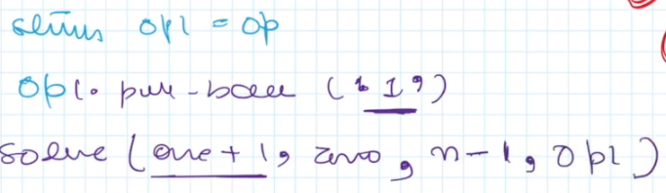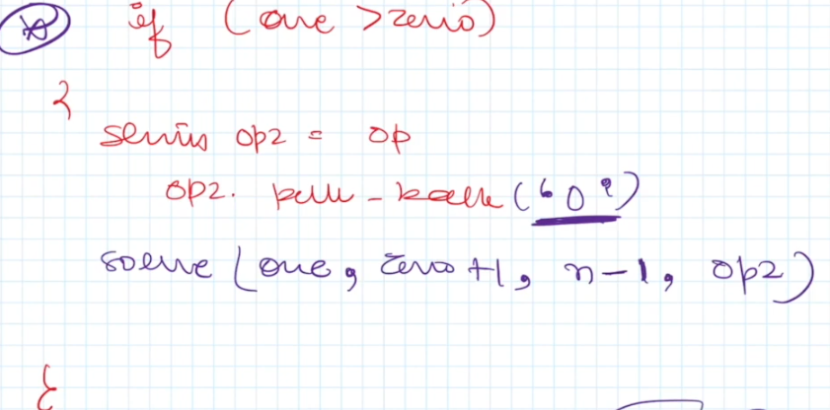

Josephus Problem:

- using IBH method.

- input:

N – total number of people.

K – the person’s position who’s going to die while counting.

- output: return the position of person who is going to survive.

- so here we are recursively defining the which kth person going to die and restart the count from k+1 position, until 1 person remains.

Dry run example

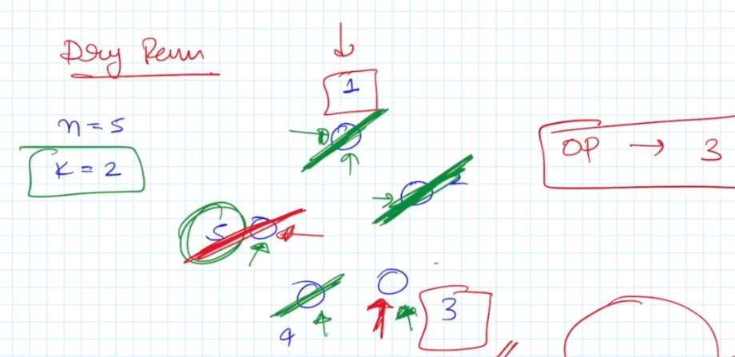

- after deleting number, we shift the position of numbers in array.

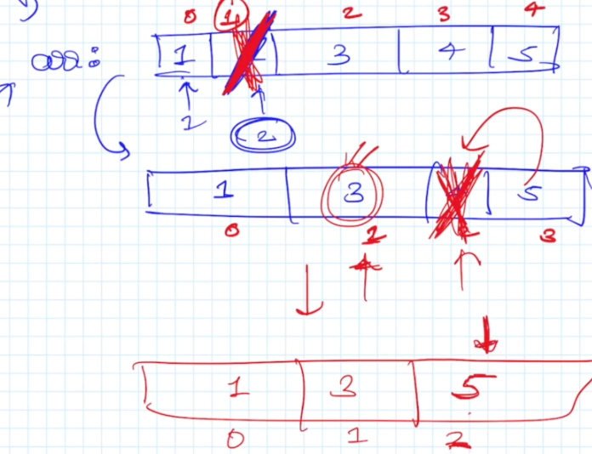

- to find the next index we can use : (current + k - 1) % size gives the index of next person who is going to die.

* Hypothesis:

- solve(array, k) : returns the position of last alive person.

- after deleting the number, shift all the next numbers to the one position ahead.

* Base condition:

- if (vect.size() == 1)

* Induction:

- every time when element gets deleted, we do, not require it anymore, so there is nothing to do in induction step.

Code:

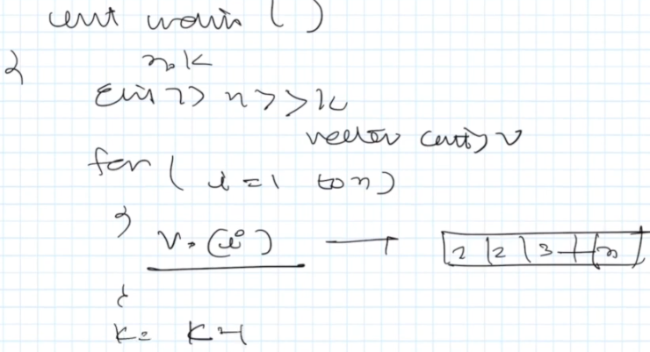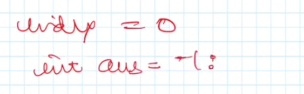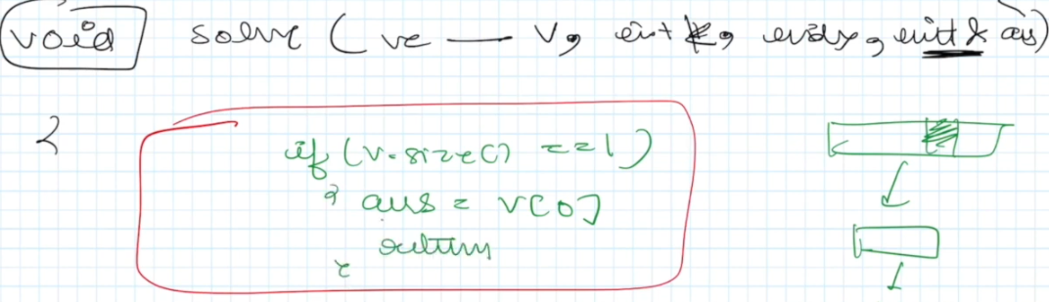

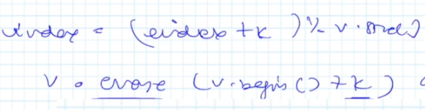

- in above, 2nd line , in place of `k` there should be `index`.

